**La sala de la cocina**

**Español Ingles Números en español Números en ingles**

Muebles Furniture Tres mil Three thousand

Televisor Television Cuatro mil Four thousand

Sofá Sofa Cinco mil Five thousand

Floreros Vases Seis mil Six thousand

Centro de mesa Centerpiece Siete mil Seven thousand

Cuadros Picture Ocho mil Eight thousand

Espejo Mirror Nueve mil Nine thousand

Cojines Cushions Diez mil Ten thousand

Lámparas Lamps

Ventanas Windows

Cortinas Curtains

Chimenea Chimney

Sofá cama Sofa bed

Portarretratos Photo frames

Aire condicionado Air conditioner

Repisas shelves

Reloj watch

[[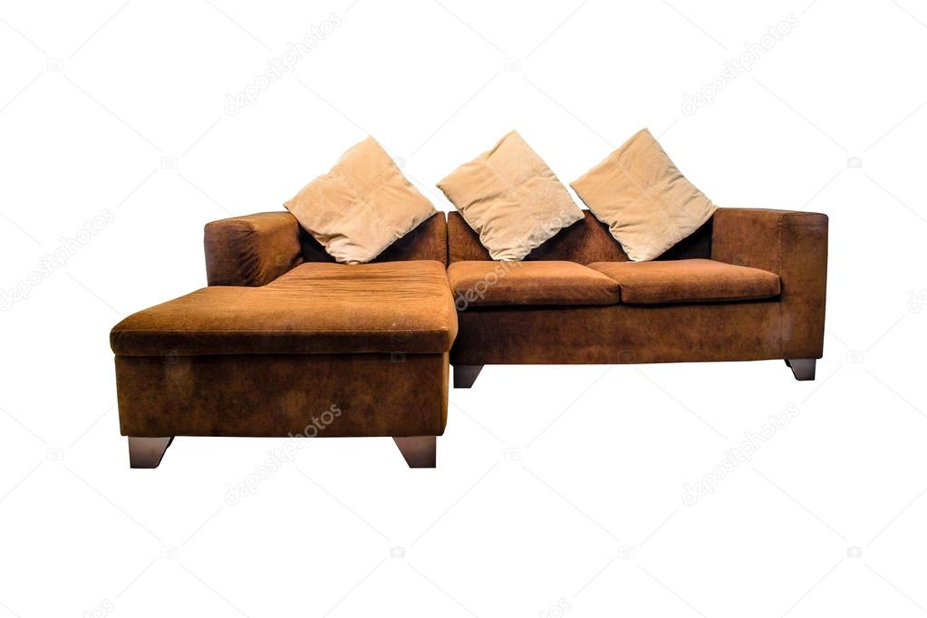](https://www.google.com/url?sa=i&rct=j&q=&esrc=s&source=images&cd=&ved=2ahUKEwjq9rDC3M7lAhUIzlkKHRKFAMoQjRx6BAgBEAQ&url=https://sp.depositphotos.com/77800322/stock-photo-sofa-furniture-on-white-background.html&psig=AOvVaw2did31jN1kXip6YqFJh1Cg&ust=1572893884080325) [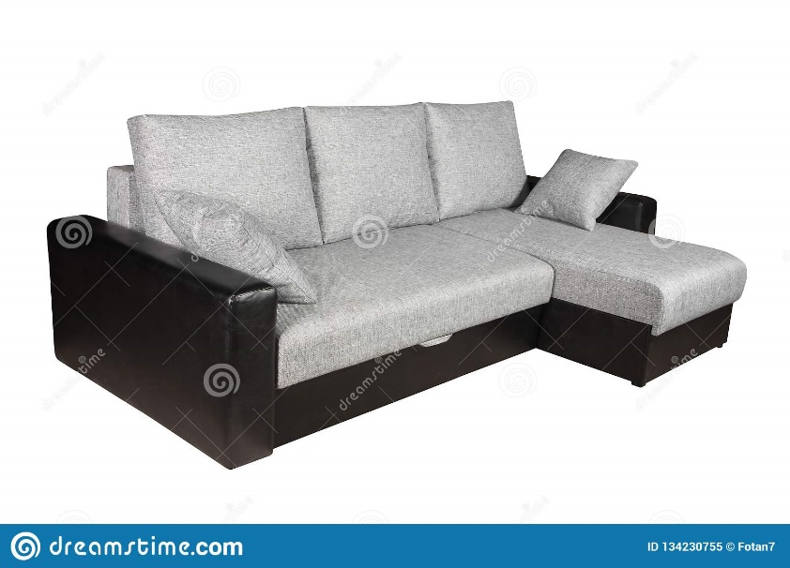](https://www.google.com/url?sa=i&rct=j&q=&esrc=s&source=images&cd=&ved=2ahUKEwiAn-at387lAhXxs1kKHVkMBCQQjRx6BAgBEAQ&url=https://es.dreamstime.com/muebles-blancos-del-sof%C3%A1-aislados-en-el-fondo-blanco-image134230755&psig=AOvVaw2did31jN1kXip6YqFJh1Cg&ust=1572893884080325)](https://www.google.com/url?sa=i&rct=j&q=&esrc=s&source=images&cd=&ved=2ahUKEwjq9rDC3M7lAhUIzlkKHRKFAMoQjRx6BAgBEAQ&url=https%3A%2F%2Fsp.depositphotos.com%2F77800322%2Fstock-photo-sofa-furniture-on-white-background.html&psig=AOvVaw2did31jN1kXip6YqFJh1Cg&ust=1572893884080325" \t "_blank)

[[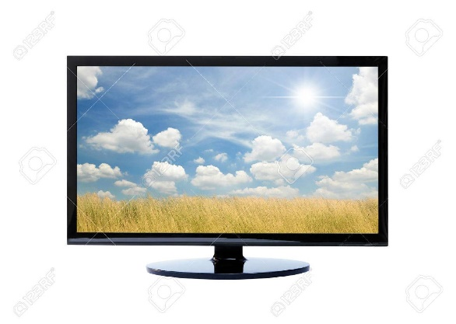](https://www.google.com/url?sa=i&rct=j&q=&esrc=s&source=images&cd=&ved=2ahUKEwjMlpH7387lAhWQtlkKHYDzAUcQjRx6BAgBEAQ&url=https://es.123rf.com/photo_50212658_la-televisi%C3%B3n-y-la-naturaleza-en-el-fondo-blanco.html&psig=AOvVaw2ouQkErJMsASwDKN9in6Ge&ust=1572894819022266) [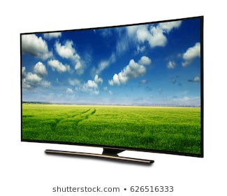](https://www.google.com/url?sa=i&rct=j&q=&esrc=s&source=images&cd=&ved=2ahUKEwiMwYiY4M7lAhUx1VkKHcuYDK4QjRx6BAgBEAQ&url=https://www.shutterstock.com/es/search/televisor%2Bfondo%2Bblanco?section%3D1%26category%3DNature%26safe%3Dtrue%26search_source%3Dbase_related_searches&psig=AOvVaw2ouQkErJMsASwDKN9in6Ge&ust=1572894819022266)](https://www.google.com/url?sa=i&rct=j&q=&esrc=s&source=images&cd=&ved=2ahUKEwiAn-at387lAhXxs1kKHVkMBCQQjRx6BAgBEAQ&url=https%3A%2F%2Fes.dreamstime.com%2Fmuebles-blancos-del-sof%25C3%25A1-aislados-en-el-fondo-blanco-image134230755&psig=AOvVaw2did31jN1kXip6YqFJh1Cg&ust=1572893884080325" \t "_blank)

[[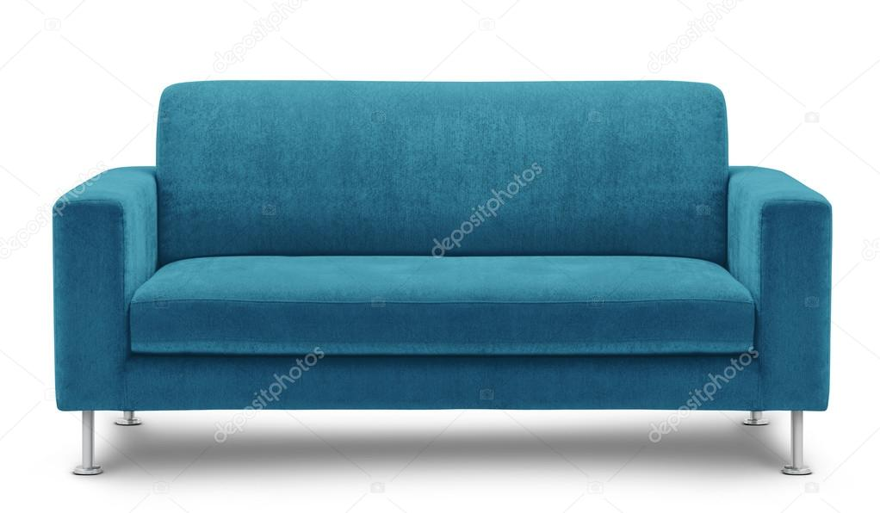](https://www.google.com/url?sa=i&rct=j&q=&esrc=s&source=images&cd=&ved=2ahUKEwjoi6XA4M7lAhUpzlkKHQUYBjYQjRx6BAgBEAQ&url=https://sp.depositphotos.com/29982189/stock-photo-sofa-furniture-isolated-on-white.html&psig=AOvVaw3IV3Jugt0R_7uEkquziAKp&ust=1572894956572599) [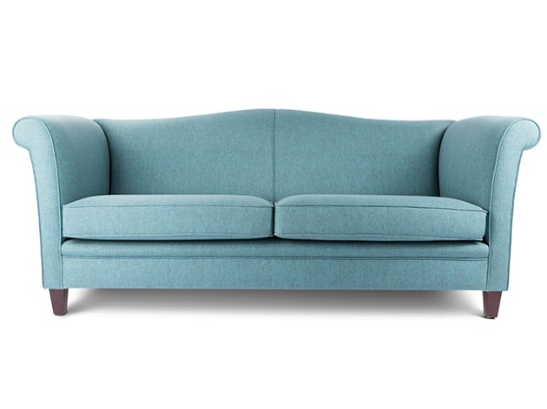](https://www.fotografiaecommerce.com/portfolio-item/i-home-design/)](https://www.google.com/url?sa=i&rct=j&q=&esrc=s&source=images&cd=&ved=2ahUKEwjoi6XA4M7lAhUpzlkKHQUYBjYQjRx6BAgBEAQ&url=https%3A%2F%2Fsp.depositphotos.com%2F29982189%2Fstock-photo-sofa-furniture-isolated-on-white.html&psig=AOvVaw3IV3Jugt0R_7uEkquziAKp&ust=1572894956572599" \t "_blank)

[[](https://www.google.com/url?sa=i&rct=j&q=&esrc=s&source=images&cd=&ved=2ahUKEwjppO_44M7lAhWs1FkKHanDAkwQjRx6BAgBEAQ&url=https://es.123rf.com/photo_50321524_flor-en-el-florero-fondo-blanco-aislado-.html&psig=AOvVaw36mI9My-YOeXEbp5dAo_Hi&ust=1572895081742567) [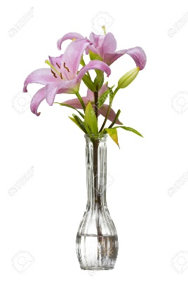](https://es.123rf.com/photo_25675455_lirio-de-d%C3%ADa-rosa-en-un-florero-aislado-en-un-fondo-blanco.html)](https://www.google.com/url?sa=i&rct=j&q=&esrc=s&source=images&cd=&ved=2ahUKEwjppO_44M7lAhWs1FkKHanDAkwQjRx6BAgBEAQ&url=https%3A%2F%2Fes.123rf.com%2Fphoto_50321524_flor-en-el-florero-fondo-blanco-aislado-.html&psig=AOvVaw36mI9My-YOeXEbp5dAo_Hi&ust=1572895081742567" \t "_blank)

[[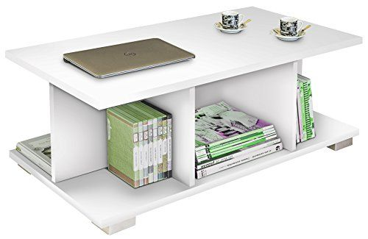](https://www.google.com/url?sa=i&rct=j&q=&esrc=s&source=images&cd=&ved=2ahUKEwirnYSr4c7lAhUG11kKHYHzC_MQjRx6BAgBEAQ&url=https://mesasdecentro.eu/comprar/mesa-de-centro-color-blanco-brillo-de-salon-comedor-5-compartimentos-tapas-de-22mm-para-salon-comedor-90cm-ancho-x-50cm-fondo-x-35cm-altura/&psig=AOvVaw0o7LONdeefY72fBETdE95s&ust=1572895175549093) [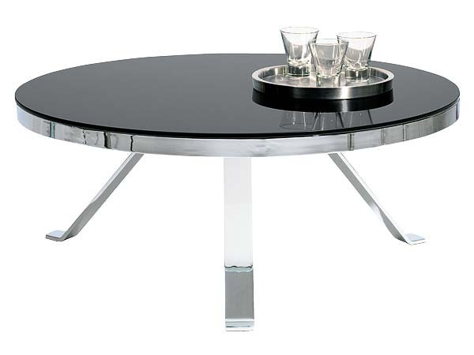](https://www.google.com/url?sa=i&rct=j&q=&esrc=s&source=images&cd=&ved=2ahUKEwjyxrPE4c7lAhXvt1kKHQtaCToQjRx6BAgBEAQ&url=http://nuevo-estilo.micasarevista.com/ideas-decoracion/como-decorar-el-salon&psig=AOvVaw0o7LONdeefY72fBETdE95s&ust=1572895175549093)](https://www.google.com/url?sa=i&rct=j&q=&esrc=s&source=images&cd=&ved=2ahUKEwirnYSr4c7lAhUG11kKHYHzC_MQjRx6BAgBEAQ&url=https%3A%2F%2Fmesasdecentro.eu%2Fcomprar%2Fmesa-de-centro-color-blanco-brillo-de-salon-comedor-5-compartimentos-tapas-de-22mm-para-salon-comedor-90cm-ancho-x-50cm-fondo-x-35cm-altura%2F&psig=AOvVaw0o7LONdeefY72fBETdE95s&ust=1572895175549093" \t "_blank)

[[](https://www.google.com/url?sa=i&rct=j&q=&esrc=s&source=images&cd=&ved=2ahUKEwjSq6uA5s7lAhVmuVkKHeJWA5cQjRx6BAgBEAQ&url=https://www.pinterest.es/pin/151152131223273690/&psig=AOvVaw0laCD8v_12Au2UKRgBj55O&ust=1572896441916469) [](https://www.google.com/url?sa=i&rct=j&q=&esrc=s&source=images&cd=&ved=2ahUKEwiU2oaM5s7lAhVG1lkKHcZGDdMQjRx6BAgBEAQ&url=https://www.pinterest.es/pin/130111876712943883/&psig=AOvVaw0laCD8v_12Au2UKRgBj55O&ust=1572896441916469)](https://www.google.com/url?sa=i&rct=j&q=&esrc=s&source=images&cd=&ved=2ahUKEwjSq6uA5s7lAhVmuVkKHeJWA5cQjRx6BAgBEAQ&url=https%3A%2F%2Fwww.pinterest.es%2Fpin%2F151152131223273690%2F&psig=AOvVaw0laCD8v_12Au2UKRgBj55O&ust=1572896441916469" \t "_blank)

[[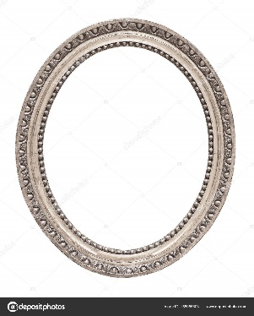](https://www.google.com/url?sa=i&rct=j&q=&esrc=s&source=images&cd=&ved=2ahUKEwi9_9-y5s7lAhWntlkKHR6mBT0QjRx6BAgBEAQ&url=https://sp.depositphotos.com/158055808/stock-photo-frame-for-paintings-mirrors-or.html&psig=AOvVaw18OD6mPfpZd093Qo6R-ojc&ust=1572896545293278) ](https://www.google.com/url?sa=i&rct=j&q=&esrc=s&source=images&cd=&ved=2ahUKEwjSq6uA5s7lAhVmuVkKHeJWA5cQjRx6BAgBEAQ&url=https%3A%2F%2Fwww.pinterest.es%2Fpin%2F151152131223273690%2F&psig=AOvVaw0laCD8v_12Au2UKRgBj55O&ust=1572896441916469" \t "_blank)

[[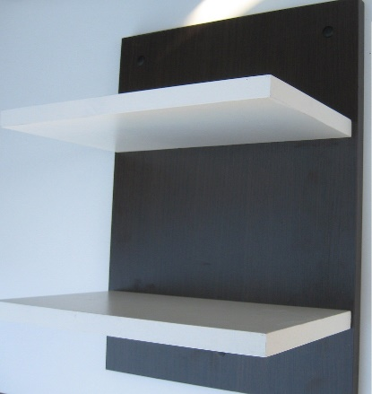](https://articulo.mercadolibre.com.ar/MLA-618590257-repisa-flotante-blanco-fondo-negro-o-wengue-oferta-_JM) [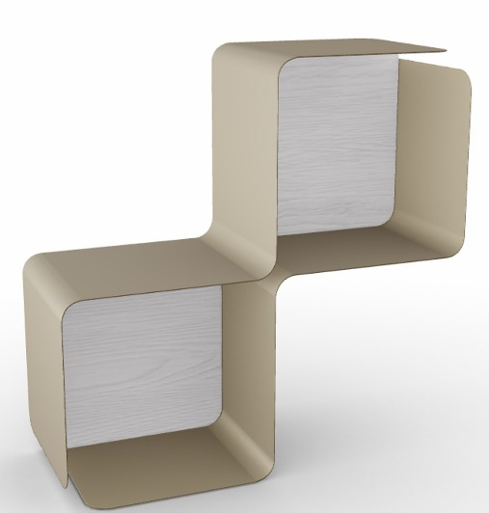](https://www.google.com/url?sa=i&rct=j&q=&esrc=s&source=images&cd=&ved=2ahUKEwi-8rvF587lAhXlqlkKHeaTAjEQjRx6BAgBEAQ&url=https://akabani.com/producto/repisa-fractal-con-fondo-blanco/&psig=AOvVaw3EV9PJfEzg99YOyygYtxU8&ust=1572896793919733)](https://articulo.mercadolibre.com.ar/MLA-618590257-repisa-flotante-blanco-fondo-negro-o-wengue-oferta-_JM" \t "_blank)

[[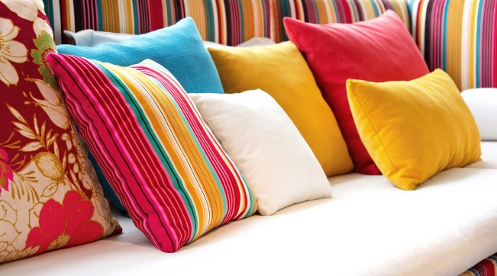](https://www.google.com/url?sa=i&rct=j&q=&esrc=s&source=images&cd=&ved=2ahUKEwj3oOW86M7lAhUKzlkKHf1bBgsQjRx6BAgBEAQ&url=https://elcomercio.pe/casa-y-mas/decoracion/consejos-escoger-cojines-tus-muebles-203561-noticia/&psig=AOvVaw3QNwsKZM2ijqJL59O38udi&ust=1572897093416142) [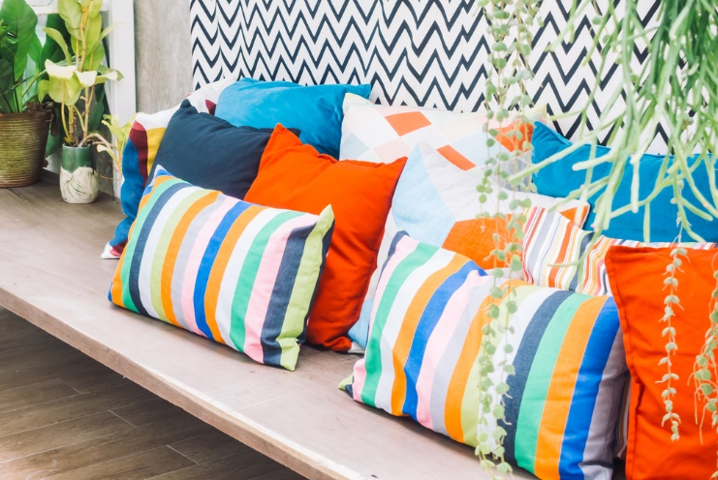](https://www.google.com/url?sa=i&rct=j&q=&esrc=s&source=images&cd=&ved=2ahUKEwiOrPnW6M7lAhWm1FkKHe_MAh0QjRx6BAgBEAQ&url=https://mueblesparaexteriores.com/cojines-para-exterior-2/&psig=AOvVaw3QNwsKZM2ijqJL59O38udi&ust=1572897093416142)](https://www.google.com/url?sa=i&rct=j&q=&esrc=s&source=images&cd=&ved=2ahUKEwj3oOW86M7lAhUKzlkKHf1bBgsQjRx6BAgBEAQ&url=https%3A%2F%2Felcomercio.pe%2Fcasa-y-mas%2Fdecoracion%2Fconsejos-escoger-cojines-tus-muebles-203561-noticia%2F&psig=AOvVaw3QNwsKZM2ijqJL59O38udi&ust=1572897093416142" \t "_blank)

[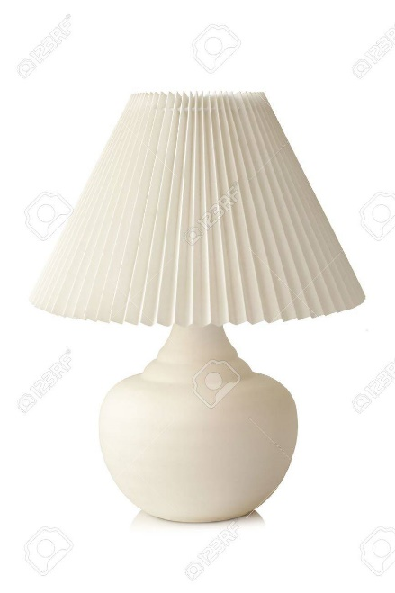 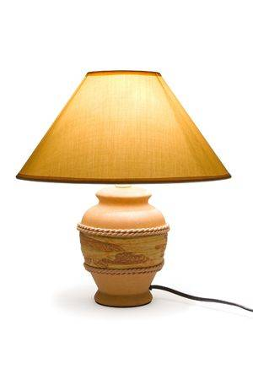](https://www.google.com/url?sa=i&rct=j&q=&esrc=s&source=images&cd=&ved=2ahUKEwj3oOW86M7lAhUKzlkKHf1bBgsQjRx6BAgBEAQ&url=https%3A%2F%2Felcomercio.pe%2Fcasa-y-mas%2Fdecoracion%2Fconsejos-escoger-cojines-tus-muebles-203561-noticia%2F&psig=AOvVaw3QNwsKZM2ijqJL59O38udi&ust=1572897093416142" \t "_blank)

[[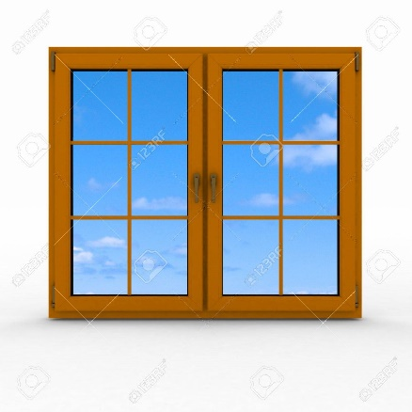](https://www.google.com/url?sa=i&rct=j&q=&esrc=s&source=images&cd=&ved=2ahUKEwjYnvfT7tDlAhXPxFkKHehpCYoQjRx6BAgBEAQ&url=https%3A%2F%2Fes.123rf.com%2Fphoto_21321196_3d-cerr%25C3%25B3-la-ventana-de-pl%25C3%25A1stico-en-el-fondo-blanco.html&psig=AOvVaw0QMWY9uDxjgdzJc4pJcyn_&ust=1572967482106843)[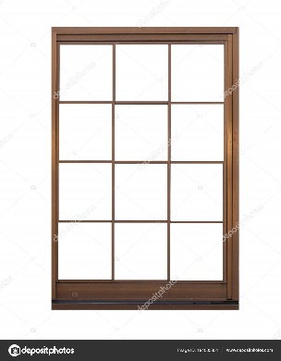](https://sp.depositphotos.com/194005354/stock-photo-brown-metal-window-frame-isolated.html)](https://www.google.com/url?sa=i&rct=j&q=&esrc=s&source=images&cd=&ved=2ahUKEwjYnvfT7tDlAhXPxFkKHehpCYoQjRx6BAgBEAQ&url=https%3A%2F%2Fes.123rf.com%2Fphoto_21321196_3d-cerr%25C3%25B3-la-ventana-de-pl%25C3%25A1stico-en-el-fondo-blanco.html&psig=AOvVaw0QMWY9uDxjgdzJc4pJcyn_&ust=1572967482106843" \t "_blank)

[[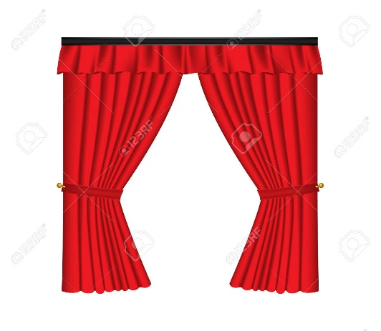](https://www.google.com/url?sa=i&rct=j&q=&esrc=s&source=images&cd=&ved=2ahUKEwiB78Wt79DlAhVCu1kKHRgrAkMQjRx6BAgBEAQ&url=https%3A%2F%2Fes.123rf.com%2Fphoto_72988258_red-cortinas-de-lujo-y-cortinas-sobre-fondo-blanco-ilustraci%25C3%25B3n-vectorial-realista.html&psig=AOvVaw1fflwHJP9rQ0I4Se7iUpRG&ust=1572967563417469)[](https://www.google.com/url?sa=i&rct=j&q=&esrc=s&source=images&cd=&ved=2ahUKEwiv64uA8NDlAhUtq1kKHVYxAKUQjRx6BAgBEAQ&url=https%3A%2F%2Fes.dreamstime.com%2Ffotos-de-archivo-libres-de-regal%25C3%25ADas-cortinas-amarillas-aisladas-en-el-fondo-blanco-image30630128&psig=AOvVaw1fflwHJP9rQ0I4Se7iUpRG&ust=1572967563417469)](https://www.google.com/url?sa=i&rct=j&q=&esrc=s&source=images&cd=&ved=2ahUKEwiB78Wt79DlAhVCu1kKHRgrAkMQjRx6BAgBEAQ&url=https%3A%2F%2Fes.123rf.com%2Fphoto_72988258_red-cortinas-de-lujo-y-cortinas-sobre-fondo-blanco-ilustraci%25C3%25B3n-vectorial-realista.html&psig=AOvVaw1fflwHJP9rQ0I4Se7iUpRG&ust=1572967563417469" \t "_blank)

[[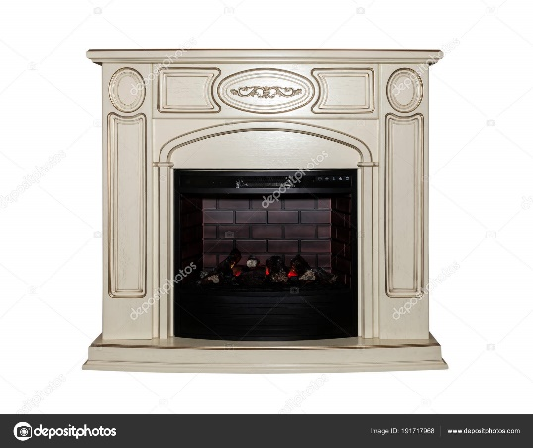](https://sp.depositphotos.com/191717968/stock-photo-fireplace-isolated-on-white-background.html)[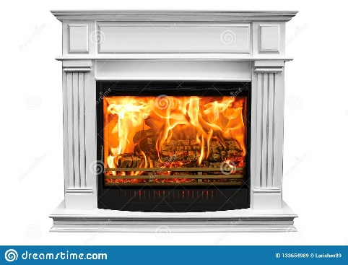](https://www.google.com/url?sa=i&rct=j&q=&esrc=s&source=images&cd=&ved=&url=https%3A%2F%2Fes.dreamstime.com%2Fchimenea-blanca-ardiente-aislada-en-el-fondo-blanco-image133654989&psig=AOvVaw2h1e8y1zdS2rtYGzRmIXcI&ust=1572967600602732)](https://www.google.com/url?sa=i&rct=j&q=&esrc=s&source=images&cd=&ved=2ahUKEwiB78Wt79DlAhVCu1kKHRgrAkMQjRx6BAgBEAQ&url=https%3A%2F%2Fes.123rf.com%2Fphoto_72988258_red-cortinas-de-lujo-y-cortinas-sobre-fondo-blanco-ilustraci%25C3%25B3n-vectorial-realista.html&psig=AOvVaw1fflwHJP9rQ0I4Se7iUpRG&ust=1572967563417469" \t "_blank)

[[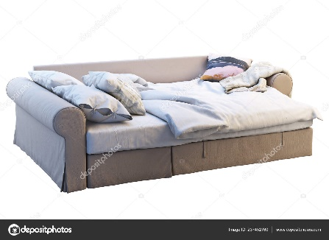](https://www.google.com/url?sa=i&rct=j&q=&esrc=s&source=images&cd=&ved=2ahUKEwiulqrM8NDlAhUtvlkKHXEID7UQjRx6BAgBEAQ&url=https%3A%2F%2Fsp.depositphotos.com%2F237452760%2Fstock-photo-render-beige-fabric-sofa-bed.html&psig=AOvVaw2ms5LFmjOg_31in-v1YlA3&ust=1572967615967852)[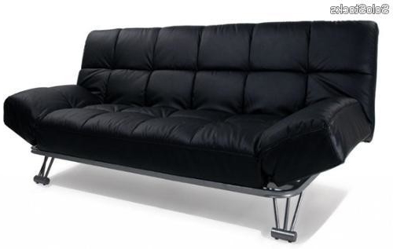](https://www.google.com/url?sa=i&rct=j&q=&esrc=s&source=images&cd=&ved=2ahUKEwjD5MOj8dDlAhVOrVkKHYY-AnsQjRx6BAgBEAQ&url=http%3A%2F%2Fsharonleal.me%2Fsofa-cama-piel%2Fsofa-cama-piel-nkde-sofa-cama-dream-3-plazas-simil-piel-en-negro-barato%2F&psig=AOvVaw2ms5LFmjOg_31in-v1YlA3&ust=1572967615967852)](https://www.google.com/url?sa=i&rct=j&q=&esrc=s&source=images&cd=&ved=2ahUKEwiulqrM8NDlAhUtvlkKHXEID7UQjRx6BAgBEAQ&url=https%3A%2F%2Fsp.depositphotos.com%2F237452760%2Fstock-photo-render-beige-fabric-sofa-bed.html&psig=AOvVaw2ms5LFmjOg_31in-v1YlA3&ust=1572967615967852" \t "_blank)

[[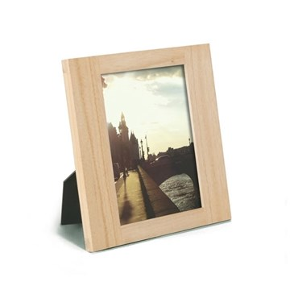](https://www.puntodesign.com.uy/portaretratos-modelo-simple-de-13x18cm)[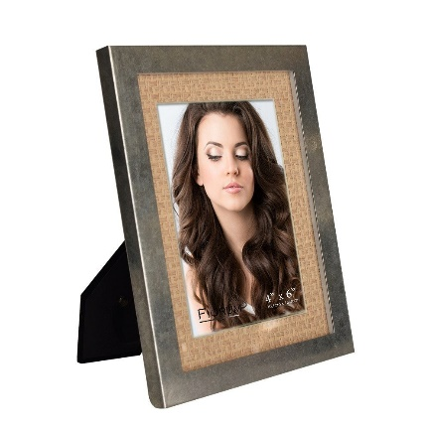](https://www.google.com/url?sa=i&rct=j&q=&esrc=s&source=images&cd=&ved=2ahUKEwjE24X48dDlAhUCrlkKHRTRDgsQjRx6BAgBEAQ&url=https%3A%2F%2Fizy.com.mx%2Fproductos%2Fportaretrato-plata-beige%2F5x7&psig=AOvVaw0GR1p4aCy4tFIzHnj8yCa9&ust=1572968316445702)](https://www.puntodesign.com.uy/portaretratos-modelo-simple-de-13x18cm" \t "_blank)

[[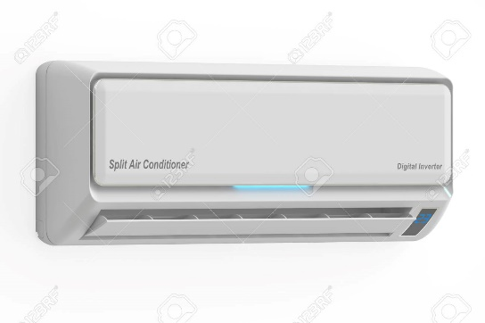](https://www.google.com/url?sa=i&rct=j&q=&esrc=s&source=images&cd=&ved=2ahUKEwiK88mH8tDlAhVP11kKHXhKDS8QjRx6BAgBEAQ&url=https%3A%2F%2Fes.123rf.com%2Fphoto_58719795_aire-acondicionado-representaci%25C3%25B3n-3d-aislada-en-el-fondo-blanco.html&psig=AOvVaw2Y2x1FzEvZZgS4SIz7GobV&ust=1572967664446966)[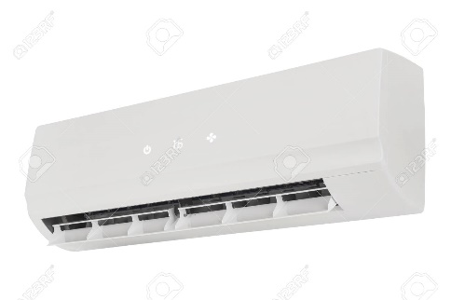](https://es.123rf.com/photo_59269445_el-color-blanco-de-la-m%C3%A1quina-de-aire-acondicionado-aislado-en-fondo-blanco.html)](https://www.google.com/url?sa=i&rct=j&q=&esrc=s&source=images&cd=&ved=2ahUKEwiK88mH8tDlAhVP11kKHXhKDS8QjRx6BAgBEAQ&url=https%3A%2F%2Fes.123rf.com%2Fphoto_58719795_aire-acondicionado-representaci%25C3%25B3n-3d-aislada-en-el-fondo-blanco.html&psig=AOvVaw2Y2x1FzEvZZgS4SIz7GobV&ust=1572967664446966" \t "_blank)

[[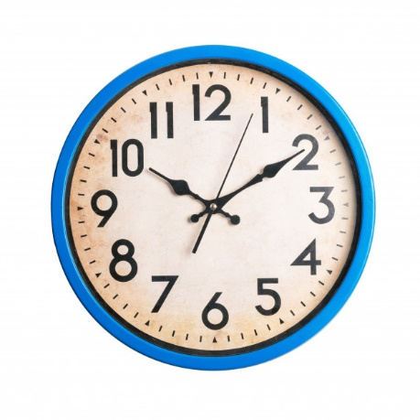](https://www.google.com/url?sa=i&rct=j&q=&esrc=s&source=images&cd=&ved=2ahUKEwiP6JyE89DlAhULwlkKHeCbBZIQjRx6BAgBEAQ&url=https%3A%2F%2Fwww.freepik.es%2Ffotos-premium%2Freloj-vendimia-sobre-fondo-blanco-aislado_2023102.htm&psig=AOvVaw1nDDwWeJdez6MtUizV_lGj&ust=1572968596465666)[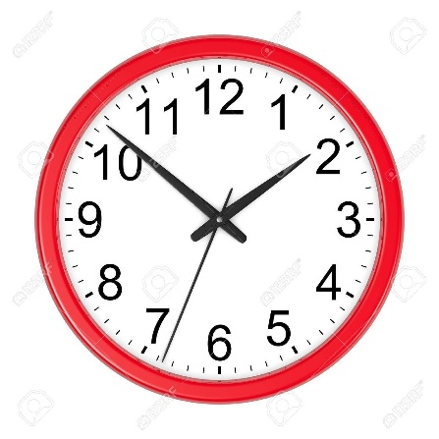](https://www.google.com/url?sa=i&rct=j&q=&esrc=s&source=images&cd=&ved=2ahUKEwiy-eHm8tDlAhUv1lkKHfqeCBsQjRx6BAgBEAQ&url=https%3A%2F%2Fes.123rf.com%2Fphoto_40613097_redondo-rojo-reloj-de-pared-aislada-sobre-fondo-blanco-ilustraci%25C3%25B3n-3d.html&psig=AOvVaw1nDDwWeJdez6MtUizV_lGj&ust=1572968596465666)](https://www.google.com/url?sa=i&rct=j&q=&esrc=s&source=images&cd=&ved=2ahUKEwiK88mH8tDlAhVP11kKHXhKDS8QjRx6BAgBEAQ&url=https%3A%2F%2Fes.123rf.com%2Fphoto_58719795_aire-acondicionado-representaci%25C3%25B3n-3d-aislada-en-el-fondo-blanco.html&psig=AOvVaw2Y2x1FzEvZZgS4SIz7GobV&ust=1572967664446966" \t "_blank)